Hydrological Monitoring Report

{{ report_date }}

## 

## 

## 

## 

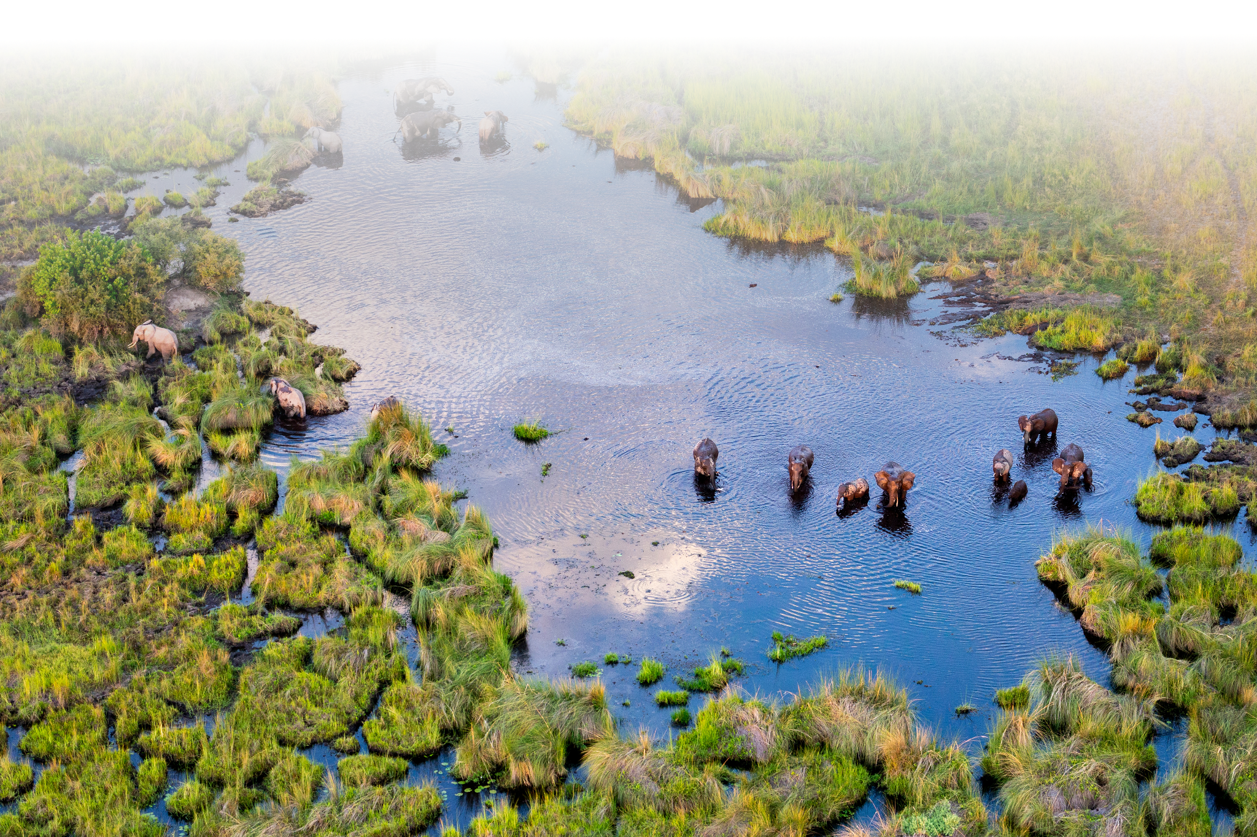

## River Depth

{% for chart in depth_chart %}{% if chart.title %}{{ chart.title }}{% endif %}{{ chart.image }}

{% endfor %}

## Dissolved Oxygen

{% for chart in do_chart %}{% if chart.title %}{{ chart.title }}{% endif %}{{ chart.image }}

{% endfor %}